Ex.no:11 Linear regression

Aim:

To implement linear regression supervised machine learning algorithm .

Description:

1. Import stats for Linear regression throughscipy
2. Providea necessary dataset through Excel file
3. Finally we canobtainthelinear regression output through matplotlib as agraph Program:

import matplotlib.pyplot as plt from scipy

import stats import pandas

df=pandas.read_excel(“Linear data (1).xlsx”)

print (“\n Original Dataframe\n”, df) slope,intercept,r,p,std_err=stats.linregress(df[“x”],df[“y”]) def myfunc(x):

return slope*x+intercept mymodel=list(map(myfunc,df[“x”])) plt.scatter(df[“x”],df[“y”]) plt.plot(df[“x”],mymodel) plt.show()

Output :

Original Dataframe

|  |  |
| --- | --- |
| X | y |
| 5 | 81 |
| 6 | 82 |
| 7 | 83 |

8 84

9 85

10 86

11 87

12 88

13 89

14 90

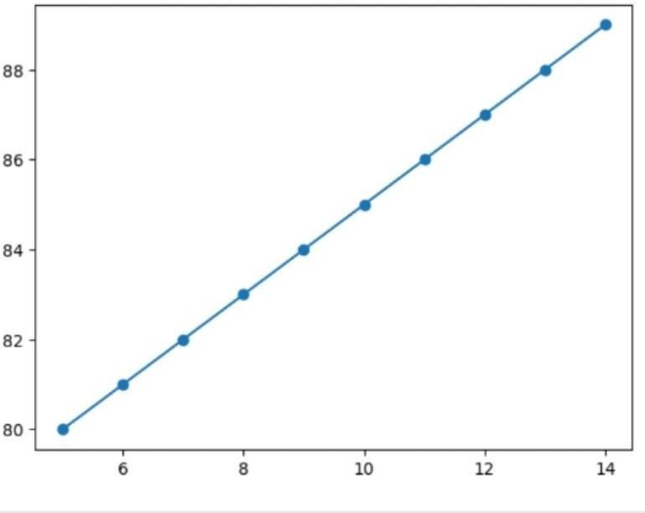

**Result:**

The programs were run successfully